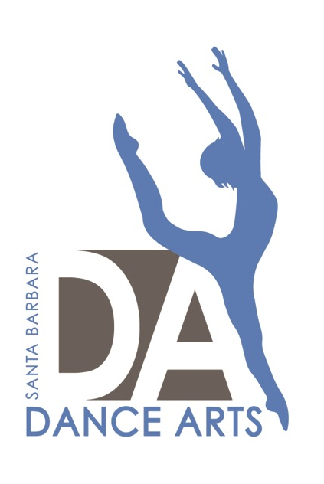 Peak Performer- Intro To Competition for Dancers Ages 6-18

Our Competitive Team is called Team Dance Arts and we are excited to have THREE offerings for our 21st Season: Senior Team, Apprentice Team, and Peak Performer directed by Lauren Serrano.

Peak Performer is the perfect introduction to competitive dance. It is for dancers who are seeking additional performance and training opportunities, while finding inspiration beyond the studio walls while achieving personal excellence and growth. We want this to be a nurturing and positive experience for you and your dancer. We are very excited to watch dancers break boundaries and develop artistry as they are exposed to the industry’s top choreographers and receive valuable feedback to grow and improve throughout the season.

Your dancer can sign up for Peak Performer on their Crew Application, or on their Company Audition Sign up Form.

Requirements
- Must be a part of Crew, Emerge, or one of our Performance Companies.
- Must be training in the discipline they would like to perform a solo.
- Must sign up through their Crew Application (available now and due April 30th or Company Audition Sign Up Form (available July 2nd and due August 10th)

Pricing: Solos, Duets, & Trios
Dancers will choose who they would like to dance with and their top three choices for their choreographer (See attached form).
- ​Solo $450 (in house choreographer)
- Duet/Trio $225 per person (in house choreographer)
- NOTE: Outside Choreographer option only available for Senior Competition Team Members.
​
Includes ​
- ​Administration cost
- choreographer fee
- 5 hours of rehearsal time with in house choreographer – set on your own time
- Free independent rehearsal space at select times- required 15 mins every other week
- 3 Saturday solo/duet/trio run through (privates can be booked (at cost) if run through cannot be attended.
Does NOT include
- ​Costumes ($50-$75 per dance)- unless you can find a rental in the loft ($20-$30)
- Extra rehearsal time with director/choreographer
- Competition/convention entrance fees $50-$125 per entry)
- Transportation/lodging- booked & arranged by dancer's family
Refunds, Withdrawal, and Re-Stage Fees
- Payments for solos, duets, & trios are collected up front and non-refundable.
- Once costumes are ordered, SBDA reserves the right to buy back the costume if for any reason dancer withdraws.
- Parents will be responsible for paying for rehearsals and re-stage fees in the event if withdrawal.

Competitions – Events TBD
- Peak Performers will be attending one competition with Crew, Emerge, Apprentice, and Senior Teams on April 12th-14th.
- Peak Performers will attend a second event on May 3rd-5th.

